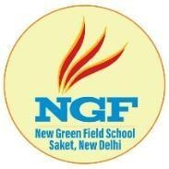
NGF JUNIOR SCHOOL MALVIYA NAGAR
Session 2022-23

NOTICE
Date: 05.11.2022

Dear Parents / Guardians,

As per the DDE circular , the school will remain closed for classes Nursery to V till 8th November due to ongoing rise in pollution level.
The test /Assessment of classes I to V scheduled for 7th November 2022 will be held on 19th December 2022 . No change in the schedule for classes VI to VIII.

Regards, PRINCIPAL

