VAN MAHOTSAV CIRCULAR FOR (Class VI to XII)

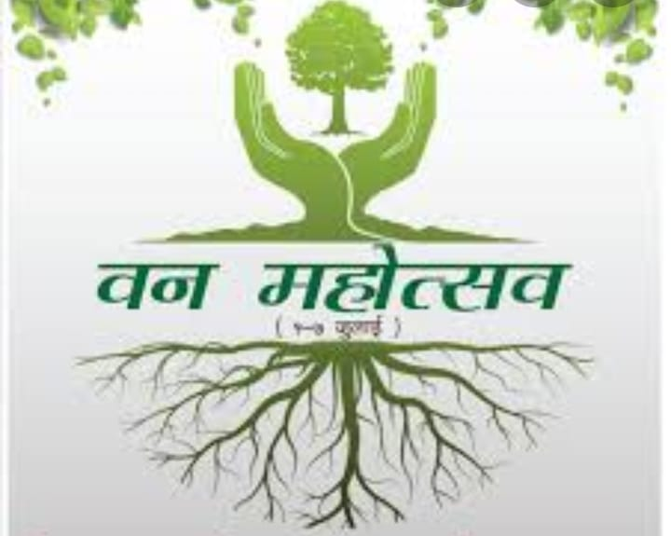

Dear Parents,

Van Mahotsav, a weeklong festival of tree planting is organized every year in the first week of July across India when millions of trees are planted. The school will be celebrating this week with activities, plantation, quizzes, poster, slogan competition, speech and poem highlighting the importance of Van Mahotsav.
In an earnest attempt to lend a green touch and to sensitize the students about their role in conserving mother earth, students are required to participate in the following activities

Tree Plantation: Students need to send their photos while planting the sapling on 4 July, 2020.

Slogan Writing: Students to make a placard with slogan and then make a video shouting aloud and showing the slogan related to Van Mahotsav on 5 July, 2020

Self composed poem: Students shall send their video while reciting a poem Hindi/English on 6 July, 2020

Poster Making : Students are required to participate in poster making activity where they will be monitored by their teachers in their respective virtual classroom. The poster making activity will be done on A3 size sheet on 7 July, 2020.
Information regarding all the above will be conveyed by the class teachers.

All the students are requested to mail their photos and videos at culturalteamhhps@gmail.com on the given dates.

We request you to motivate your child to participate in the above activities.
Students will receive participation certificate from the school.

Regards

